EXECUTIVE DATA SUMMARY: CUSTOMER RIDE SERVICE OPERATIONS
1. Business Context & Problem Framing This dataset serves as the foundational "Single Source of Truth" for evaluating urban mobility reliability and identifying operational bottlenecks for July 2024. Comprising 103,024 transactional records, the data captures a comprehensive, individual-booking grain view. The primary business objective of this dataset is to identify the root causes of supply-side ride cancellations and measure their direct impact on top-line revenue.
2. Architectural Structure & Dimensional Modeling To optimize downstream BI reporting and ensure stakeholder dashboards load instantly, the raw data was explicitly modeled into a Star Schema. The 19 distinct attributes are categorized into four strategic business dimensions:
- Entity Resolution (The Nouns): Unique identifiers (Booking_ID, Customer_ID) establish the exact grain of the Fact Table, while categorical segmentation (Vehicle_Type) is critical for analyzing product-specific supply shortages.
- Geospatial & Time-Series Drivers: Temporal data (Date) tracks daily booking volumes and demand spikes, while geographic hubs (Pickup_Location, Drop_Location) are utilized to map high-value operational zones.
- Operational Bottleneck KPIs: The definitive transaction outcome (Booking_Status) serves as the primary metric for ride completion rates. "Vehicle" and "Customer" wait times (V_TAT, C_TAT) are critical numerical KPIs used to pinpoint operational friction.
- Revenue & Root-Cause Metrics: Booking_Value represents total potential fare revenue. Qualitative cancellation logic (e.g., "Driver not moving") is explicitly used to segment operational failures and calculate supply-side revenue leakage.
3. Analytical Judgment & Data Integrity Gatekeeping To ensure the dataset was production-ready, strict ETL gatekeeping was applied. A standard "drop nulls" approach was explicitly avoided to prevent the loss of critical booking volume data and the skewing of DAU (Daily Active User) metrics.
- Continuous Variables: Missing wait times (TAT) and stakeholder ratings were filled using statistical medians to prevent extreme outliers from skewing executive KPIs.
- Categorical Variables: Missing text fields were standardized using mode imputation to ensure 100% data density.

DATA CLEANING
Executive Data Cleaning & Imputation Strategy (SSMS)
Before architecting the final Star Schema, the raw transactional dataset required strict ETL gatekeeping to resolve anomalies, missing values, and inconsistent data types. The core objective was to create a 100% dense, standardized staging table (OLA_cleaned) without dropping rows, which would have destroyed critical booking volume metrics.
The cleaning pipeline was executed in three highly optimized phases:
1. Pre-Computing Statistical Baselines (Medians)
Instead of utilizing standard averages—which are easily skewed by extreme operational outliers, such as system glitches recording 5-hour wait times—the script calculates the exact statistical median for continuous KPIs (Vehicle TAT, Customer TAT, and user ratings). By leveraging the PERCENTILE_CONT(0.5) window function and declaring these as variables upfront, the database engine stores the values in memory, preventing heavy row-by-row recalculations during the insert phase.
2. Categorical Standardization (Modes)
The raw dataset contained unstructured textual anomalies, including missing fields and the literal string text 'null'. To preserve data density for downstream categorical filtering, the script dynamically calculates the Mode (most frequent valid value) for payment methods and cancellation reasons, explicitly excluding the corrupted 'null' strings.
3. Defensive Data Engineering & Pipeline Execution
To construct the final staging table, a combination of defensive SQL functions was deployed to prevent pipeline failures and seamlessly apply the imputations:
- Safe Type Conversion: TRY_CAST was heavily utilized to enforce rigid data types (Dates and Floats). If the engine en
- countered severely corrupted text within a numeric column, it gracefully converted it to a true SQL NULL rather than throwing an error and crashing the pipeline.
- Dynamic Imputation: The ISNULL and NULLIF functions were seamlessly chained together to detect missing data and invalid text strings, instantly replacing them with the pre-calculated statistical Medians and Modes.
This rigorous process generated a mathematically sound, fully sanitized OLA_cleaned staging table, perfectly primed for Kimball dimensional modeling and Star Schema partitioning.

STAR SCHEMA ARCHITECTURE:
We do not join the tables based on the Fact table's Primary Key (Booking_ID). Instead, we join the central Fact table to the Dimension tables using Foreign Keys that map directly to the specific Primary Keys of each individual Dimension table. Here is the exact architectural breakdown of the Primary Keys (PK) and Foreign Keys (FK) used to build your OLA Star Schema.
The Core Architecture
- The Fact Table (Fact_Bookings): The Primary Key is Booking_ID. This establishes the "grain" of the table (one row = one unique ride) and other quantitative attributes.
- The Joins: To connect this Fact table to the surrounding dimensions, the following four key mappings were used:
1. The Customer Join (Entity)
- Dimension PK: Customer_ID (inside Dim_Customer)
- Fact FK: Customer_ID (inside Fact_Bookings)
- The SQL Join: ON Fact_Bookings.Customer_ID = Dim_Customer.Customer_ID
2. The Vehicle Join (Entity)
- Dimension PK: Vehicle_Type (inside Dim_Vehicle)
- Fact FK: Vehicle_Type (inside Fact_Bookings)
- The SQL Join: ON Fact_Bookings.Vehicle_Type = Dim_Vehicle.Vehicle_Type
3. The Temporal Join (Time-Series)
- Dimension PK: Date (inside Dim_Date)
- Fact FK: Date (inside Fact_Bookings)
- The SQL Join: ON Fact_Bookings.Date = Dim_Date.Date
4. The "Junk Dimension" Join (The Masterstroke)
Because you cannot use heavy text strings (like cancellation reasons) as an efficient primary key, you engineered a new one:
- Dimension PK: Status_ID (A newly created integer Surrogate Key inside Dim_Ride_Status)
- Fact FK: Status_ID (Inside Fact_Bookings)
- The SQL Join: ON Fact_Bookings.Status_ID = Dim_Ride_Status.Status_ID

DASHBOARD
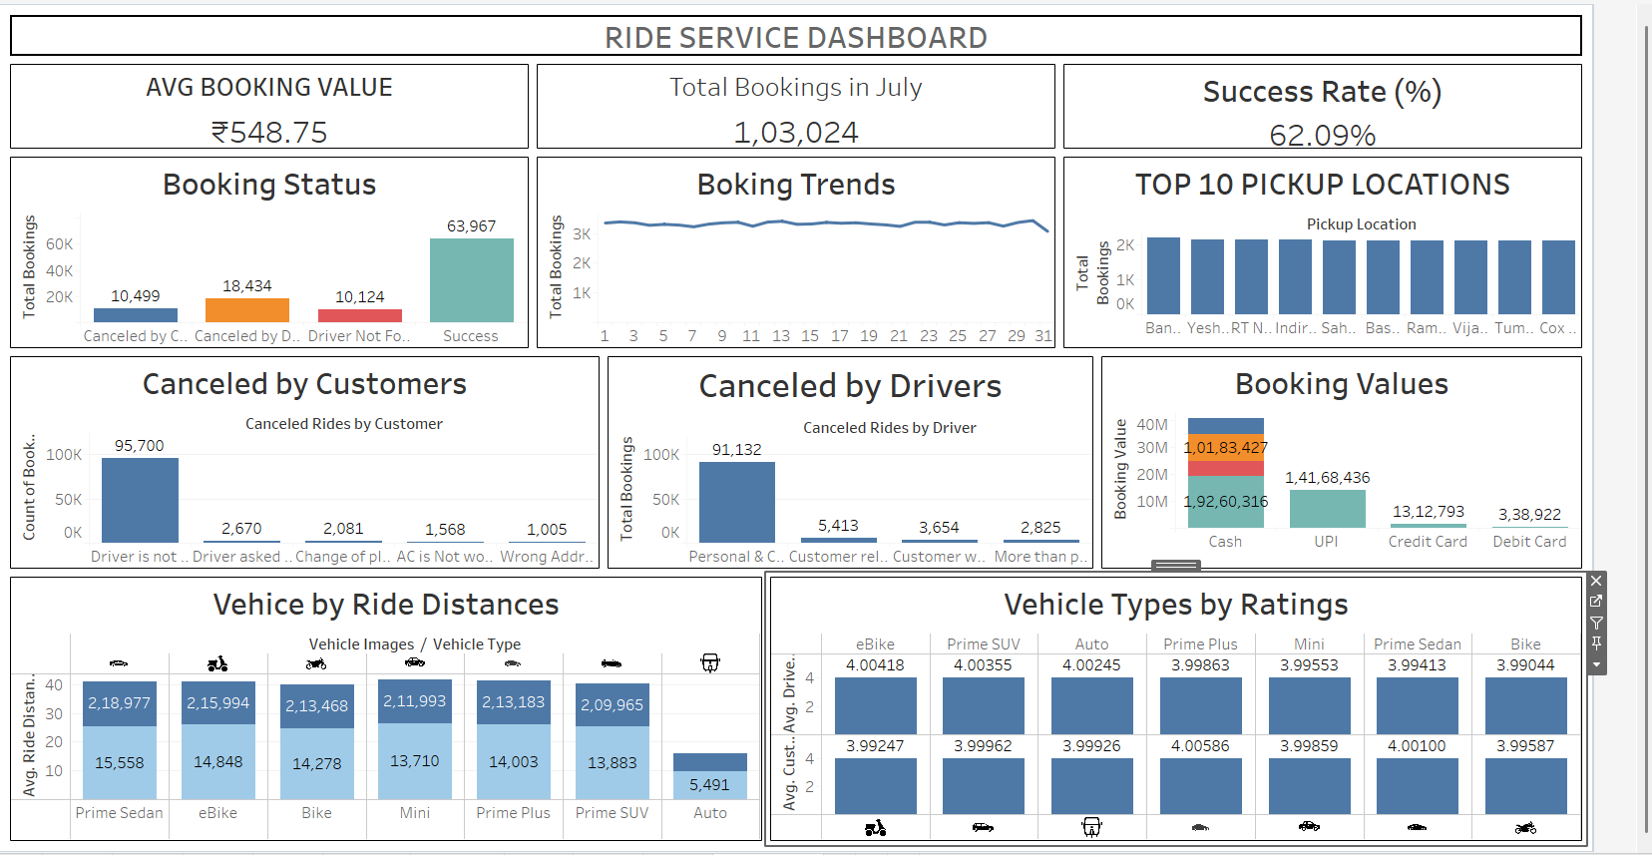

Project Report: Ride Service Dashboard Interpretation
1. The KPIs (Executive Summary)
The dashboard immediately grounds the executive team in the scale and financial reality of the operation before diving into granular analysis.
- Total Bookings in July (1,03,024): Establishes the high-volume operational scale.
- Avg Booking Value (₹548.75): Sets the baseline financial metric for calculating total revenue and potential leakage.
- Success Rate (62.09%): This is the most critical framing metric of the entire report. It instantly signals to stakeholders that nearly 38% of all attempted transactions are failing, setting the stage for the root-cause analysis below.

2. Defining the Bottleneck (Supply vs. Demand)
Once the 38% failure rate is established, the next logical business question is: Is this a lack of customer demand, or a failure of operational supply?
- Booking Status (Bar Chart): This visual definitively proves the problem is supply-side. "Canceled by Driver" (18,434) and "Driver Not Found" (10,124) combined represent over 28,500 failed rides. This dwarfs the "Canceled by Customer" metric (10,499). This insight redirects stakeholder focus away from marketing (demand generation) and toward fleet operations (supply retention).
- Booking Trends (Line Chart): The daily booking volume is a flat, consistent line across all 31 days. Insight: The 38% failure rate is a systemic, daily operational bottleneck, not an isolated incident caused by a single holiday or weather event.
- Top 10 Pickup Locations (Bar Chart): The volume is evenly distributed across major hubs (Bangalore, Yeshwanthpur, RT Nagar, etc.). Insight: The supply-side friction is a city-wide operational failure, not an issue isolated to a specific geographic "dead zone."

3. Root-Cause Analysis & Financial Risk
Here, the dashboard identifies why drivers are failing to complete rides and ties it to financial risks.
- Booking Values by Payment Method (Stacked Bar): Cash transactions account for the vast majority of the booking volume (over ₹1.92 Crore), dwarfing UPI and cards. Actionable Insight: The overwhelming dominance of cash creates operational risk. Drivers may be selectively canceling non-cash rides or leveraging cash dominance to bypass platform rules. This directly supports the recommendation to aggressively incentivize UPI payments.
- Canceled by Drivers (Bar Chart): Excluding the successful rides, the highest cancellation driver is "Personal & Car related issue" (5,413). Actionable Insight: Fleet maintenance or shift-fatigue is the primary driver-initiated bottleneck.
- Canceled by Customers (Bar Chart): Even when customers cancel, the data points to driver failure. The top reasons are "Driver is not moving towards pickup" (2,670) and "Driver asked to cancel" (2,081). Actionable Insight: Customers are churning because drivers are trying to game the system (forcing the customer to cancel to avoid driver-side penalties).
Strategic Recommendations & Action Plan
1. Mitigate Payment-Driven Cancellations
- Recommendation: Reduce the operational risk associated with the overwhelming dominance of cash transactions.
- Action: Launch targeted customer promotions (e.g., 5% discount) for UPI and Credit/Debit card payments. Concurrently, restrict drivers with high cancellation rates from accepting cash-only rides.
2. Correct Driver-Side Behavior
- Recommendation: Eliminate the supply-side bottleneck caused by drivers refusing to move or forcing customers to cancel.
- Action: Implement an automated GPS-triggered penalty system. If a driver accepts a ride but does not move toward the pickup location within 3 minutes, automatically reassign the ride and flag the driver's account for algorithmic de-prioritization.

3. Reduce Vehicle Maintenance Drop-Offs
- Recommendation: Address the highest driver cancellation reason ("Personal & Car related issues") to keep fleet supply high.
- Action: Partner with local service centers to offer subsidized, preventative maintenance for high-utilization vehicle categories (specifically Prime Sedans and eBikes) once they hit specific distance thresholds.
4. Optimize BI Reporting (Version 2.0)
- Recommendation: Enhance dashboard readability for the operations management team.
- Action: Apply a strict page-level filter to the "Canceled by Customer" and "Canceled by Driver" charts to explicitly exclude "Success" statuses. This will dynamically scale the charts to reveal the true distribution of root-cause anomalies.

